
MINISTRY OF EDUCATION, CULTURE AND RESEARCH
OF THE REPUBLIC OF MOLDOVA
Technical University of Moldova
Faculty of Computers, Informatics and Microelectronics
Department of Software Engineering and Automation

Clepicova Polina FAF-243

Report
Laboratory Works No.3-4
Operating Systems
Topics: The Command Line, The xv6 Shell

Checked by:
Reitman P., univ.assistant
FCIM, UTM

Chișinău – 2026

TABLE OF CONTENTS
LABORATORY 5 - PART 1 3
PART 1. OBSERVE ANSWERS 4
LABORATORY 5 - PART 2 5
PART 2. OBSERVE ANSWERS 6
LABORATORY 5 - PART 3 7
PART 3. OBSERVE ANSWERS 8
LABORATORY 5 - PART 4 10
PART 4. OBSERVE ANSWERS 11
SUMMARY FOR LABORATORY 5 12
LABORATORY 6 – PART 1 14
PART 1. OBSERVE ANSWERS 15
LABORATORY 6 – PART 2 16
PART 2. OBSERVE ANSWERS 16
LABORATORY 6 – PART 3 18
PART 3. OBSERVE ANSWERS 20
LABORATORY 6 – PART 4 21
Part 4. Observe Answers 21
SUMMARY FOR LABORATORY 6 22

LABORATORY 5 - PART 1
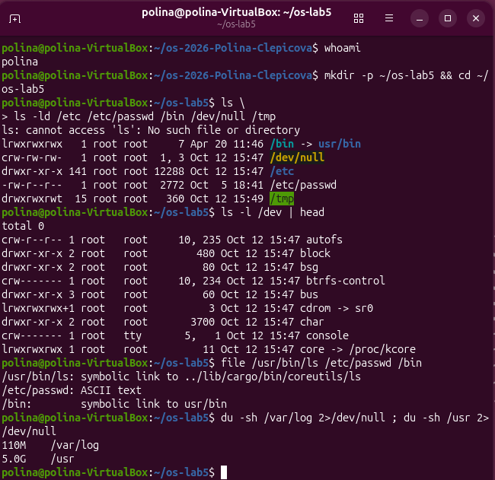
Figure 5.1.1 – File Types
Inspection of system file types, link targets (/bin pointing to usr/bin), device nodes in /dev, and disk space comparison between /var/log and /usr.

PART 1. OBSERVE ANSWERS
- File types based on the first letter in ls -l:
/etc: d (directory)
/etc/passwd: - (regular file)
/bin: l (symbolic link)
/dev/null: c (character device)
/tmp: d (directory)
- What /bin is on the system:
On modern Linux distributions, /bin is a symbolic link pointing to usr/bin (or /usr/bin) due to the UsrMerge filesystem reorganization.
- Devices in /dev:
Character device: /dev/null (or /dev/tty, /dev/zero)
Block device: /dev/sda (or /dev/nvme0n1, /dev/loop0)
- Size comparison between /var/log and /usr:
/usr is significantly larger than /var/log. On this system, /usr occupies several gigabytes containing installed binaries, packages, and system libraries, whereas /var/log only occupies a few megabytes to gigabytes for log files.

LABORATORY 5 - PART 2
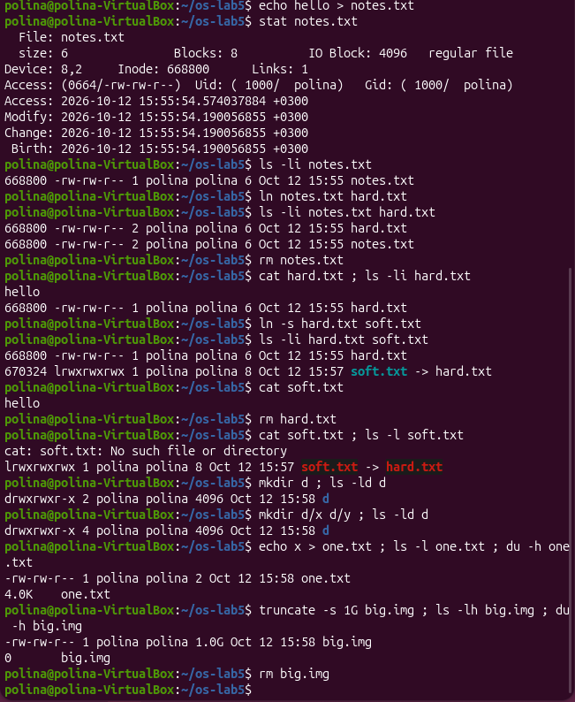
Figure 5.2.1 – Inodes and Links
Inode metadata verification using stat, behavior of hard links versus broken symbolic links upon target deletion, directory link count scaling, and sparse file creation with truncate.

PART 2. OBSERVE ANSWERS
- Inode number and link count in stat:
The Inode field indicates the unique inode number of the file. The Links field (or Nlink) tells how many hard links (names) point to that inode.
- Why hard.txt could be read after rm notes.txt, and what rm removes:
The rm command (unlink) only removes the filename entry notes.txt from the directory and decreases the inode link count by 1. Since hard.txt still points to the same inode, the link count remains above zero, and the actual file data is preserved. The rm command only truly deletes file data when the link count reaches 0 and no running processes hold open file descriptors.
- Why cat soft.txt failed at the end, and its size:
The command cat soft.txt failed with "No such file or directory" because soft.txt is a symbolic link containing the text string path "hard.txt". Removing hard.txt left soft.txt pointing to a missing file (a dangling or broken symlink). The size of soft.txt is 8 bytes because the path string "hard.txt" is exactly 8 characters long.
- Explanation of directory link counts:
A newly created directory d has 2 links: one from its parent directory entry d, and one from its internal . entry. Creating two subdirectories d/x and d/y increases the count to 4 links because each subdirectory contains a .. entry pointing back to d.
- Disk space allocation (2-byte vs 1 GB file):
A 2-byte file uses 4.0K of disk space because the file system allocates storage in minimum block units (typically 4 KB). The 1 GB file created with truncate uses 0 bytes of disk space because it is a sparse file. The truncate command updates the file size metadata in the inode without actually allocating physical data blocks on disk.

LABORATORY 5 - PART 3
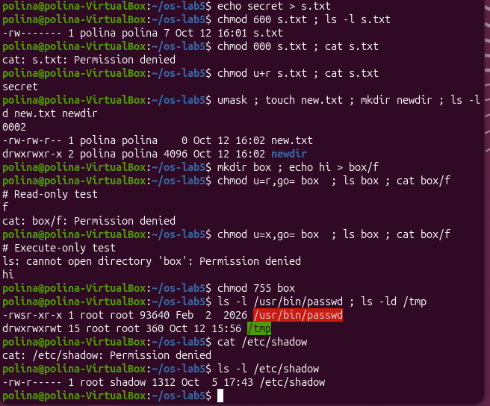
Figure 5.3.1 - Permissions
File permission management with chmod and umask, distinction between directory read (r) and execute (x) access modes, and inspection of special bits (SetUID on passwd and Sticky Bit on /tmp).

PART 3. OBSERVE ANSWERS
- Permission strings and real-world uses:
600 = rw------- (Used for private configuration files or SSH private keys like ~/.ssh/id_rsa)
644 = rw-r--r-- (Used for standard readable configuration files like /etc/passwd)
755 = rwxr-xr-x (Used for executable programs in /usr/bin or shared directories)
700 = rwx------ (Used for private directories restricted exclusively to the owner, like ~/.gnupg)
- Why ownership does not help with chmod 000:
The Linux kernel enforces permission bits for every requested operation. Setting mode 000 removes read permissions even for the owner. File ownership grants the right to modify permission bits via chmod, but does not bypass active permission checks during read or write calls.
- Explanation of umask:
The umask defines default permission masks that are subtracted from standard base modes (666 for files, 777 for directories). With a default umask of 0022:
new.txt permissions: 666 - 022 = 644 (rw-r--r--)
newdir permissions: 777 - 022 = 755 (rwxr-xr-x)
- Explanation of the box directory experiment:
Read permission (r): Allows listing the file names inside the directory (ls box works), but without execute (x) permission, file metadata and file contents cannot be accessed (cat box/f fails).
Execute permission (x): Allows entering the directory and accessing a file if its name is known (cat box/f works), but without read (r) permission, directory contents cannot be enumerated (ls box fails).
- Meaning of s bit in /usr/bin/passwd and t bit in /tmp:
SetUID bit (s) on /usr/bin/passwd: Runs the binary with the effective user privileges of the file owner (root). passwd needs SetUID to update user password entries inside /etc/shadow, which is restricted to root.
Sticky bit (t) on /tmp: Ensures that users in a shared directory can only delete or rename files that they own.

LABORATORY 5 - PART 4
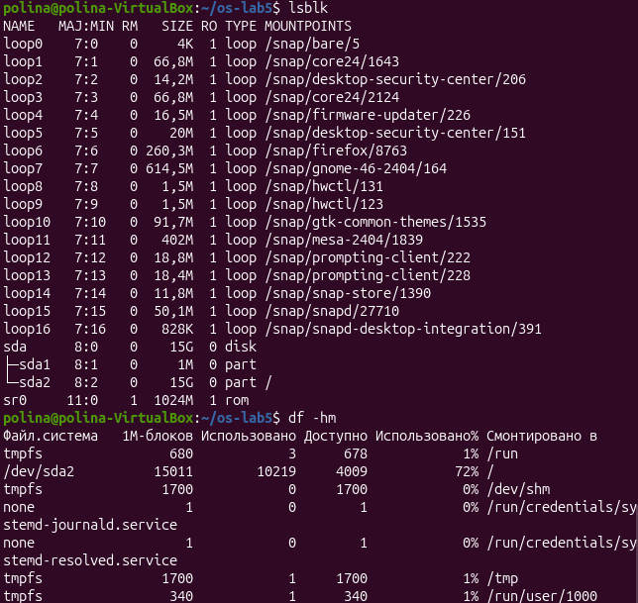
Figure 5.4.1 – Disks and Proc
Disk partition topology via lsblk and df -hm, alongside hardware and process diagnostics extracted from the pseudo-filesystem /proc.

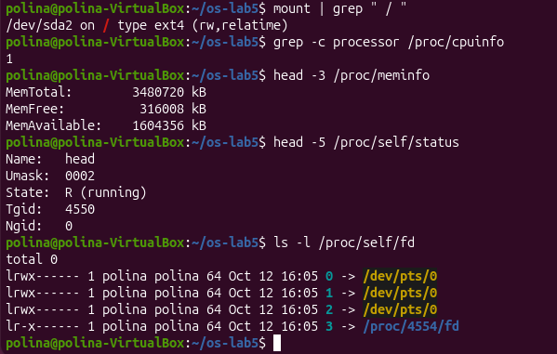
Figure 5.4.2 - Disks and Proc

PART 4. OBSERVE ANSWERS
- Disk structure drawing:
[Disk: /dev/sda] (or /dev/nvme0n1)
├── Partition 1: /dev/sda1 (vfat) -> Mounted at /boot/efi
└── Partition 2: /dev/sda2 (ext4) -> Mounted at /
- Root file system fullness:
The root filesystem fullness percentage is obtained from the Use% column in the output of df -hm for the mount point /.
- CPU cores and RAM from /proc:
CPU cores: Count obtained via grep -c processor /proc/cpuinfo.
RAM: Total memory size retrieved from the MemTotal line in /proc/meminfo.

- Program name in /proc/self/status:
It shows Name: head (or cat). This happens because /proc/self is a dynamic symbolic link pointing to the process that is actively reading the status file at that exact instant.

SUMMARY FOR LABORATORY 5
This laboratory work provided a practical, hands-on study of the Linux file system architecture, its internal abstractions, and system administration utilities without application programming.
Key findings and achievements include:
- Directory Hierarchy and File Types Investigated the root filesystem layout, verified the modern UsrMerge scheme (where /bin acts as a symbolic link to /usr/bin), and identified various special file types, including character and block devices inside /dev.
- Inode Mechanics and Link Behavior Demonstrated that hard links share identical inode metadata and data blocks, keeping data accessible after primary entry deletion until the link count reaches zero. In contrast, symbolic links store target path strings and become dangling upon target removal. Additionally, explored sparse files, confirming how filesystem block allocation decouples file size metadata from actual disk usage.
- Access Control and Special Permission Bits Analyzed standard permission strings (rwx) and default file creation behaviors governed by umask. Established the functional distinction between directory read permissions (listing directory entries) and execute permissions (traversing and accessing known paths). Analyzed privilege escalation mechanisms through the SetUID bit on /usr/bin/passwd and deletion protection via the Sticky Bit on shared directories (/tmp).
- Storage Mapping and Kernel Pseudo-Filesystems Mapped physical block devices to active mount points using lsblk and df, and extracted real-time system diagnostics-such as CPU core counts, total memory, and process state-directly from the kernel's virtual /proc interface.
In conclusion, the experiment successfully demonstrated the fundamental UNIX philosophy that "everything is a file," illustrating how the kernel abstracts hardware, metadata, permissions, and runtime process metrics into unified filesystem primitives.

LABORATORY 6 – PART 1
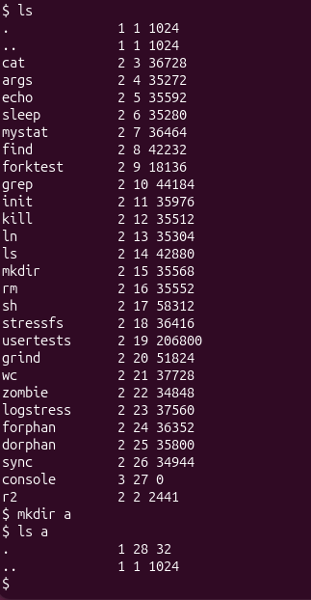
Figure 6.1.1 - Execution and error handling of report.sh
Demonstration of the default filesystem hierarchy in xv6. The ls command displays existing files alongside their corresponding file types, assigned inode numbers, and file sizes. Creating a new directory 'a' initializes an entry with a fixed baseline size of 32 bytes, which accounts for the two auto-generated directory entries (. and ..).

PART 1. OBSERVE ANSWERS
- Meaning of file types in kernel/stat.h:
Type 1 represents a Directory (T_DIR), Type 2 represents a Regular File (T_FILE), and Type 3 represents a Character Device (T_DEVICE, such as the console).
- Root directory inode and self-referencing entries:
The root directory of the xv6 filesystem always occupies inode number 1. In the root directory, both '.' (current directory) and '..' (parent directory) refer to inode 1 because the root directory acts as its own parent in the filesystem tree.
- Size of a directory entry and contents of an empty directory:
An empty directory 'a' has a size of 32 bytes. In xv6, a directory entry (struct dirent) has a fixed size of 16 bytes (2 bytes for the inode number inum plus 14 bytes for the filename string name). Therefore, 32 bytes corresponds to exactly 2 entries: '.' (pointing to directory 'a') and '..' (pointing to the root directory).

LABORATORY 6 – PART 2
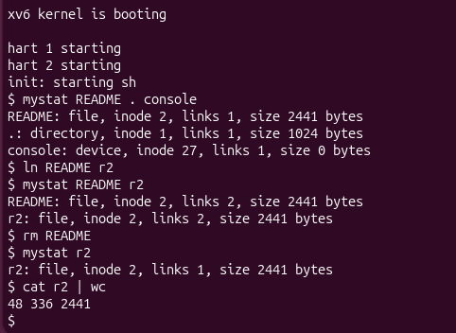
Figure 6.2.1 - The commands run in bash.
Execution and validation of the custom mystat user utility. The tool accurately decodes file types (directory, file, device) and reads inode metadata. Following the creation of a hard link (r2 pointing to README), the link count increments from 1 to 2 while sharing inode 2. Removing the original filename README decrements the link count back to 1 without destroying the underlying data blocks.

PART 2. OBSERVE ANSWERS
- Metadata changes after ln and rm:
After running 'ln README r2', both 'README' and 'r2' refer to inode 2, and the link count (nlink) increases from 1 to 2. After executing 'rm README', the entry 'README' is unlinked, but 'r2' continues to point to inode 2 with its link count decremented back to 1. The data size (2441 bytes) and underlying disk blocks remain unchanged.
- Unlink logic in sys_unlink and block deallocation:
In kernel/sysfile.c within the sys_unlink function, the hard link count is decremented via 'ip->nlink--'. The actual file data blocks are freed when the inode link count reaches 0 AND the active in-memory reference count (ip->ref) drops to 0 (handled inside iput/iuncache in kernel/fs.c).
- Fields of struct dinode in kernel/fs.h:
An xv6 disk inode structure (struct dinode) contains the following fields:
short type (file type: directory, file, or device)
short major (major device number)
short minor (minor device number)
short nlink (number of hard links referencing this inode)
uint size (file size measured in bytes)
uint addrs[NDIRECT+1] (array of block addresses: 12 direct block addresses plus 1 indirect block address)

LABORATORY 6 – PART 3
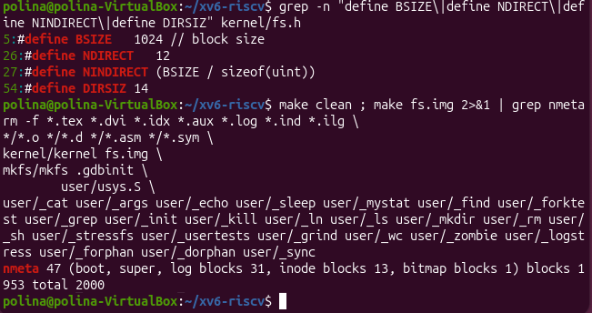
Figure 6.3.1 - Limits

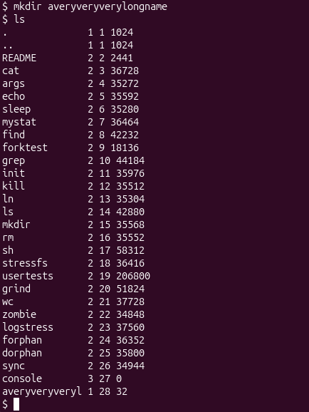
Figure 6.3.2 - Limits
Inspection of filesystem limits defined in kernel/fs.h and analysis of disk layout parameters printed during image compilation. The screenshot demonstrates how the 14-character limit (DIRSIZ = 14) automatically truncates long directory names such as 'averyveryverylongname' down to 'averyveryveryl' inside the directory table.

PART 3. OBSERVE ANSWERS
- Filename truncation for long directory names:
The command 'ls' displays 'averyveryverylongname' as 'averyveryveryl'. This behavior is controlled by the constant DIRSIZ = 14 defined in kernel/fs.h, which sets the maximum fixed length allocated for filename strings inside struct dirent.
- Maximum file size calculation in xv6:
The maximum file size supported by xv6 is calculated as follows:
Block size (BSIZE) = 1024 bytes
Direct blocks (NDIRECT) = 12 blocks
Indirect blocks (NINDIRECT) = BSIZE / sizeof(uint) = 1024 / 4 = 256 blocks
Total blocks per file = 12 + 256 = 268 blocks
Maximum file size = 268 blocks * 1024 bytes = 274,432 bytes (approximately 268 KB).
- Disk block distribution from nmeta output:
Based on the compilation metadata printed by make fs.img:
Total disk size = 2000 blocks (FSSIZE = 2000)
Metadata blocks (nmeta) = 46 blocks (comprising boot block, super block, journal log blocks, inode blocks, and free bitmap blocks)
Log blocks = 30 blocks (LOGSIZE = 30)
Inode blocks = 13 blocks (NINODES = 200)
Data blocks = 1954 blocks (2000 total blocks minus 46 metadata blocks).

LABORATORY 6 – PART 4

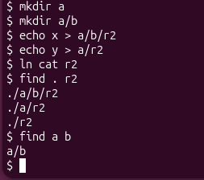
Figure 6.4.1 – Find

Testing of the custom recursive find command across nested directory trees. The utility traverses subdirectories, compares name strings, avoids infinite recursive loops by explicitly skipping dot (.) and dot-dot (..) directory entries, and properly closes file descriptors to prevent descriptor exhaustion.

Part 4. Observe Answers
The custom find utility successfully walked nested directories recursively, printing all path entries whose final path component matches the target string. Skipping '.' and '..' entries prevented infinite recursive loops, and explicitly closing directory handles ensured that the process remained well within the 16 open file descriptor limit.

SUMMARY FOR LABORATORY 6
This laboratory work explored the low-level design and practical mechanics of the xv6 Unix-like operating system file system.
Key accomplishments and findings include:
- Directory Structure and Entry Layout: Inspected file types (directory, regular file, device) using kernel definitions in kernel/stat.h. Verified the internal structure of directory entries, confirming that fixed 16-byte dirent structures store a 2-byte inode index and a 14-byte name string.
- Inode Operations and Hard Link Management: Developed the mystat user utility to query file system metadata. Confirmed that hard links share identical inode numbers and verified that data blocks are released only when both the inode link count (nlink) and the active memory reference count drop to zero during unlinking operations.
- File System Limits and Disk Topology: Analyzed structural constraints in kernel/fs.h. Explained filename truncation resulting from DIRSIZ = 14, calculated the maximum file size supported by combined direct and single-indirect block addressing (274,432 bytes), and mapped the disk layout across journal log, inode table, and data block regions.
- Recursive Tree Traversal: Implemented the find program using directory reading and recursion. The utility navigated subdirectories while successfully avoiding infinite loops through explicit dot (.) and dot-dot (..) checks, maintaining proper resource cleanup by closing directory file descriptors.
In conclusion, the experiment provided a practical understanding of fundamental OS file system abstractions, demonstrating how inodes, directory tables, hard links, and block addressing operate within a minimal kernel environment.

